Study Guide
College of Dentistry, Lahore Medical & Dental College
Oral Medicine & Diagnosis Curriculum (2023-2024)

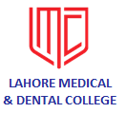

Course Director:

Dr. Khurram Nadeem BDS, MCPS (OMFS), CMT (UHS)
Associate Professor/Head of the Department

Contributors:

Dr. Aneela Amjad Bsc, BDS, MCPS (OMFS), CHPE Associate Professor
Dr. Amber Salimi BDS Demonstrator
Dr. Nawal Talat BDS Demonstrator

INDEX

Sr. # | Contents | Page #
01 | Introduction | 3
02 | Department of Oral Medicine | 5
03 | Teaching & Clinical Schedule | 7
04 | Duty Roster of Oral Medicine Department | 8
05 | Duties of Demonstrators | 10
06 | Oral Medicine and Diagnosis Table of Specifications | 12
07 | Curriculum objectives | 16
08 | Course outline | 17
09 | Evaluation | 24
10 | Curriculum Schedule | 26
11 | Clinical Demonstration Schedule | 31
12 | References and supporting material | 32

Introduction
Oral Medicine is the part of dentistry that is involved in the diagnosis and non-surgical treatment of primary or secondary disease involving the oral and para-oral structures including lymph node, salivary gland and TMJ disorders. Also it is concerned with the oral manifestations of systemic diseases and the oral and dental care of patients with special needs.

Oral Medicine provides an essential link between dentistry and medicine, practitioners in this field must possess a thorough knowledge of basic physiological and pathological mechanisms that contribute to health and disease.To become competent in the practice of oral medicine, must perform a proper assessment of patients including history taking and physical examination, and develop a management plan.

Learning Outcomes:
At the end of academic session the learner will be able to:
- Demonstrate an understanding of the aetiology, pathogenesis, epidemiology and clinical presentation of the common disorders of oral & para-oral structures including salivary glands, TMJ and pain disorders.
- Illustrate the diagnostic basis for diseases and conditions in the oral & para-oral structures. Achieve cognitive proficiency in differential diagnosis for common oral lesions or diseases.
- Identify the Signs and symptoms of systemic diseases including standard treatment emphasizing on
diseases causing oral manifestation, or diseases prone to oral infection, diseases enhancing existing oral diseases, and diseases affecting dental team.
- Diagnose and appropriately manage patients presenting to oral medicine clinic including orofacial pain of odontogenic and non-odontogenic origin
- Mention and demonstrate their Oral manifestations and the dental considerations in management of these patients.
- Develop the skills of analytical problem solving, investigation, and self-development in the field of oral medicine.
- Express the basic knowledge regarding mechanisms of action of antibiotics, antiviral and antifungal drugs, and their therapeutic uses particularly in dental practice.
- Define and describe risk factors, prevention and control of common oral & systemic diseases.
- To identify, manage and where required provide basic and immediate life support for adult and paediatric medical emergencies and ensure patient safety as a priority.

Department of Oral Medicine

Consultant: Demonstrators:
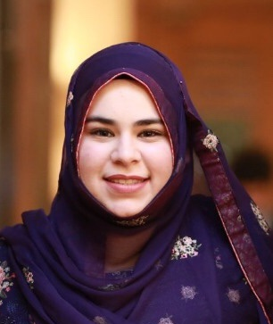
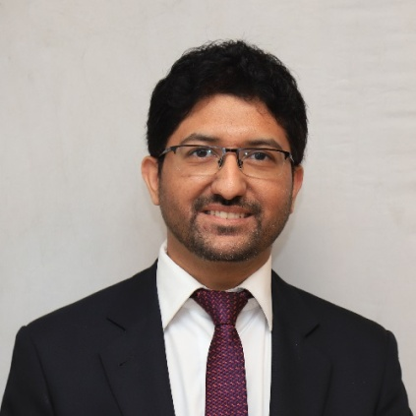

Dr. Khurram Nadeem Dr. Amber Salimi
BDS, MCPS (OMFS) BDS
Associate Professor Demonstrator
Head of Oral Medicine Department

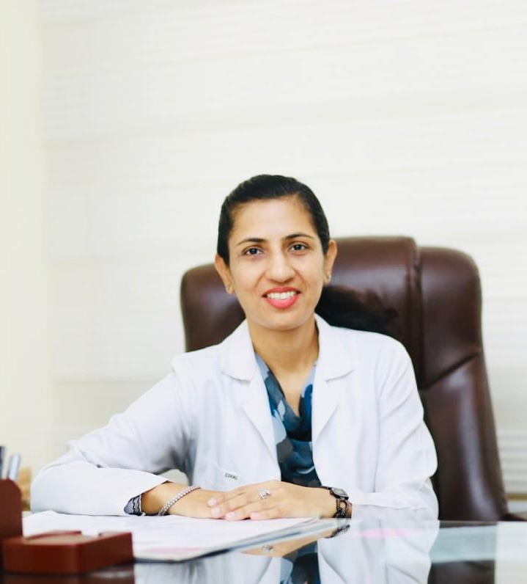

Dr. Aneela Amjad Dr. Nawal Talat
Bsc, BDS, MCPS (OMFS), CHPE BDS
Associate Professor Demonstrator

Dental Assistant:

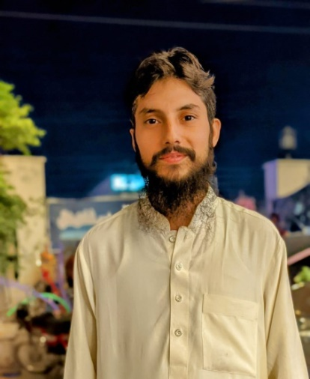
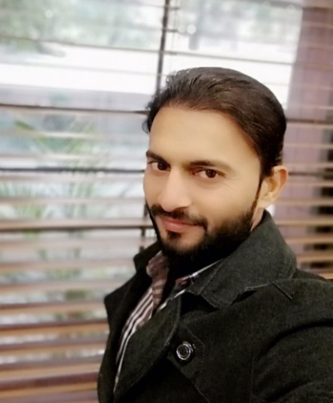

Muhammad Naveed Muhammad Sami
Dental Assistant/Attendant Dental Assistant/Attendant

3rd Year BDS Lecture Teaching Schedule

Day | Timings
Monday | -----------
Tuesday | Lecture 10:45am – 11:30am
Wednesday | Lecture 8:00am – 8:45am
Thursday | -----------
Friday | -----------

Clinical Teaching Schedule

Day | Timings
Monday | Clinical Practice 9:30am – 2:30pm
Tuesday | Clinical Practice 11:30am – 2:30pm
Wednesday | -----------
Thursday | -----------
Friday | Clinical Practice 9:30am – 1:00pm

Duty Roster of Oral Medicine Department
Dr. Khurram Nadeem (Associate Prof/HOD)
Monday
8:00 -9:00 am  Outdoor  Supervision of demonstrators and house officers | 9:00 -10:00 am  Students demonstration  10:00 am- 1:15 pm  Students supervision in OM (Oral Medicine clinic) | 1:30-2:30 pm  Lecture/Test preparation  Test Assessment  Case Discussion
Tuesday
8:00-9:30 am  Outdoor  Lecture preparation  Student’s Mentorship | 10:45-11:30 am  Lecture Oral Medicine | 11:45am- 2:30pm  Students demonstration  Students supervision in OM (Oral Medicine clinic)
Wednesday
8:00-8:45 am  Lecture Oral Medicine | 8:30-9:30 am  Departmental Seminar | 9:30 am-2:30 pm  Case discussion in  Oral Medicine Clinic
Thursday
8:00 -11:00 am  Outdoor  Supervision of demonstrators and house officers | 11:00-11:30 am  Outdoor  Supervision of demonstrators and house officers | 11:30 am-2:30 pm  Lecture/Test preparation  Test Assessment  Case Discussion
Friday
8:00-9:30 am  Research/reading  Article writing | 9:30 am-12:00 pm  Students demonstration  Students supervision | 12:00-1:00pm  Clinical Evaluation of Students & Discussions

Dr. Aneela Amjad (Associate Professor)
Monday
8:00 -9:00 am  Outdoor  Supervision of demonstrators and house officers | 9:00 -10:00 am  Students demonstration  10:00 am- 1:15 pm  Students supervision in OM (Oral Medicine clinic) | 1:30-2:30 pm  Lecture/Test preparation  Test Assessment  Case Discussion
Tuesday
8:00-8:30 am  Outdoor  8:30-10:30 am  Lecture preparation  Student’s Mentorship | 10:45-11:30 am  Break | 11:45am- 2:30pm  Student supervision in OM Clinic  Case discussion
Wednesday
8:00-8:45 am  Lecture Oral Medicine | 8:30-9:30 am  Departmental Seminar | 9:30 am-2:30 pm  Case discussion in  Oral Medicine Clinic
Thursday
8:00 -11:00 am  Outdoor  Supervision of demonstrators and house officers | 11:00-11:30 am  Break | 11:30 am-2:30 pm  Outdoor  Supervision of demonstrators and house officers
Friday
8:00-8:30 am  Research/reading  Article writing | 8:30 am-12:00 pm  Outdoor  Student Supervision | 12:00-1:00pm  Clinical Evaluation of Students  Student Assignments & Discussions

Dr. Amber Salimi (Demonstrator)
Monday
8:00 – 12:00  Examining and treating patients, observation and guidance to house surgeons |  |  | 12:00 – 12:30  Break | 12:30 – 02:30  House surgeons seminar and case discussion
Tuesday
8:00 – 10:30  Examining and treating patients, Supervision of House Surgeons | 10:30 – 12:00  Group discussion with house surgeons |  | 12:00 – 12:30  Break | 12:30 – 2:30  Examining and treating patients, Supervision of House Surgeons
Wednesday
8:00 – 10:30  Examining and treating patients, Supervision of House Surgeons | 10:30 – 12:00  Case presentation and Group discussion with house surgeons |  | 12:00 – 12:30  Break | 12:30 – 2:30  Examining and treating patients, Supervision of House Surgeons
Thursday
8:00 – 12:00  Clinical Practice dentistry and supervision of house surgeons |  |  | 12:00 – 12:30  Break | 12:30 – 2:30  Patient examination and treatment of oral medicine patients
Friday
8:00 – 11:00  Clinical Practice dentistry, House surgeons observation and guidance |  | 11:00 – 11:30  Break |  | 11:30 – 01:00  Clinical practice in oral medicine clinic and case discussion with house surgeons

Dr. Nawal Talat (Demonstrator)
Monday
8:00 – 9:15  Diagnosis of patients and treatment of oral medicine patients. | 9:15 – 11:30  Demonstration to 3rd year BDS students |  | 11:30 – 12:00  Break |  |  |  | 12:00 – 2:30  Group discussion and supervision of 3rd year students
Tuesday
8:00 – 10:45  Diagnosis of patients and treatment of oral medicine patients | 10:45 – 11:30  Attend Oral Medicine lecture |  | 11:30 – 12:00  Break |  |  |  | 12:00 – 2:30  Supervision and demonstration of 3rd year BDS
Wednesday
8:00 – 8:15  3rd Year BDS Oral Medicine Lecture | 8:15 – 11:30  Diagnosis of patients and treatment of oral medicine patients |  | 11:30 – 12:00  Break |  |  | 12:00 – 2:30  Diagnosis of patients and treatment of oral medicine patients
Thursday
8:00 – 11:30  Diagnosis of patients, treatment of oral medicine patients and supervision of house surgeons |  | 11:30 – 12:00  Break |  |  | 12:00 – 2:30  Diagnosis of patients, treatment of oral  medicine patients HO supervision
Friday
8:00 – 9:00  Diagnosis and treatment of patients | 9:00 – 10:30  Demonstration of 3rd year BDS students |  |  | 10:30 – 11:00  Break |  |  | 11:00 – 1:00  Supervision of 3rd year students

Table of specifications
- 1.5 hrs/week × 4 = 6 lectures per month = 60 lectures per year
- 11.5 hrs/week × 8 = 92 hrs per 2 months per batch =92 clinical hrs per batch

Oral Medicine
Topic | Lecture hours | Weightage of Topic | SEQs | MCQs
Introduction to Oral Medicine: | 03 | 6% | .48 | 1
Oral Mucous Membrane: | 02 | 4% | .32 | 1
Oral ulceration: | 05 | 10% | 1 | 2
Infections: | 05 | 10% | .8 | 2
Vesiculobullous/immune mediated disorders: | 05 | 10% | .8 | 2
Oral pigmentation. | 02 | 4% | .32 | 1
Oral Precancer and cancer: | 05 | 10% | 1 | 2
Temporomandibular joint disorders: | 03 | 6% |  | 1
Salivary gland diseases: | 05 | 10% | 1 | 2
Orofacial pain: | 05 | 10% | 1 | 2
Oral manifestations of systemic diseases:  Granulomatous diseases: | 05 | 10% | 1 | 2
Medical emergencies relevant to dentistry: | 05 | 10% | 1 | 2
TOTAL | 50 | 100% | 8 | 20

Oral Diagnosis

Topic | Lecture Hours
Introduction to history taking:  - Biodata  - Presenting complaint  - History of presenting complaint  - Medical history  - Social history  - Drug history | 02
General physical examination:  - Blood pressure  - Pulse  - Respiratory rate  - Temperature | 01
Clinical examination:  Extraoral examination:  - Facial symmetry  - Pallor  - Temporomandibular joint  - Lymph nodes  Intraoral examination:  Soft Tissues:  - Labial mucosa  - Buccal mucosa  - Palatal mucosa  - Gingiva  - Tongue  - Floor of mouth  - Salivary glands  Hard tissues:  - Teeth(Morphology, Occlusion) | 02
Investigations:  - Complete blood count (CBC)  - Erythrocyte sedimentation rate (ESR)  - Serum folate,  - Blood glucose, HbA1c  - Urea  - HBsAg  - AntiHCV  - Bleeding time, Clotting time  - Liver function test (LFTS)  - Serum electrolytes  - Immunological tests  - Microbiological investigations | 2
Radiology/Imaging:  - Introduction  - Tecniques  Intraoral radiographs  - Periapical  - Occlusal  - Bitewing  Extaroral radiographs  - OPG  - Lateral Ceph  - Occipitomental view  - Submentovertex view  - PA mandible  Interpretation of radiographs  Computed tomography(C.T scan)  Cone beam computed tomography(CBCT)  PET scan  Arthroscopy  Sialography  Ultrasound  Magnetic resonance imaging(MRI)  Radioisotope studies  Oral pigmentation:  - Localized  - Syndromic  - Malignant | 04

CURRICULUM
OBJECTIVES:
At the end of the academic session the goals achieved would be;
- Understanding of the aetiology, pathogenesis, epidemiology and clinical presentation of the common disorders of oral & para-oral structures including salivary glands, TMJ and pain disorders.
- Illustration of the diagnostic basis for diseases and conditions in the oral & para-oral structures. Achieve cognitive proficiency in differential diagnosis for common oral lesions or diseases.
- Identification of the Signs and symptoms of systemic diseases including standard treatment emphasizing on diseases causing oral manifestation, or diseases prone to oral infection, diseases enhancing existing oral diseases, and diseases affecting dental team.
- Diagnose and appropriately manage patients presenting to oral medicine clinic including orofacial pain of odontogenic and non-odontogenic origin
- Mention and demonstrate their Oral manifestations and the dental considerations in management of these patients.
- Developing the skills of analytical problem solving, investigation, and self-development in the field of oral medicine.
- Express the basic knowledge regarding mechanisms of action of antibiotics, antiviral and antifungal drugs, and their therapeutic uses particularly in dental practice.
- Defining and describing the risk factors, prevention and control of common oral & systemic diseases.
- To identify, manage and where required provide basic and immediate life support for adult and paediatric medical emergencies and ensure patient safety as a priority.

Course Outline

Introduction to Oral Medicine:
Brief introduction about Oral Medicine including aim of studying Oral Medicine, terminologies used in Oral Medicine
Taking History
Clinical Examination
Investigations used in Dentistry

Oral Mucous Membrane:
Brief introduction about epithelium
Brief introduction about Connective Tissue
Keratinization
Keratinized and Non keratinized parts of the Oral Mucosa
Cells of Oral mucous membrane
Basement membrane zone
Submucosal layer
Role as barrier
Permeability
Hematinincs and oral mucous membrane
Age changes in oral mucous membrane
Regulation of production of normal oral mucous membrane

Oral ulceration:
Causes of Oral ulceration
Recurrent apthous stomatitis
RAS like oral ulceration
Behcet’s syndrome
Drugs causing oral ulceration
Trauma and oral ulceration
Oral malignancy and oral ulceration
Vesiculobullous diseases
Immunologically mediated oral ulceration

Infections:
Bacterial infections
Viral infections
Fungal infections

Vesiculobullous/immune mediated disorders:
Lichen planus
Pemphigus vulgaris
Mucous membrane pemphigoid
Erythema multiforme
Systemic lupus erythmatosis
Sclerosis
Graft versus host disease

Oral pigmentation:
Localized
Syndromic
Malignant
Others

Oral Precancer and cancer:
Precancer Lesions
Precancer Conditions
Oral squamous cell carcinoma\
Non-hodgkins lymphoma
Kaposi sarcoma

Temporomandibular joint disorders:
Classification
Myofacial pain dysfunction syndrome
Internal derangements
Management strategies

Salivary gland diseases:
Developmental
Reactive (Mucocele, retention cyst)
Infectious
Immune Mediated/Sjogren’s syndrome
Xerostomia/causes/management
Hypersalivation/causes/management & Salivary gland neoplasia

Orofacial pain:
Clinical features
Diagnosis and management
Dentoalveolar pain
Neuropathic pain
Trigeminal neuralgia
Glossopharyngeal neuralgia
Post herpetic neuralgia
Migraine
Cluster headache
Burning mouth syndrome
Frey’s syndrome

Neurological disturbance:
Facial paralysis
Sensory impairments
Multiple sclerosis
Extrapyrimidal syndrome

Oral manifestations of systemic diseases:
Oral manifestations of HIV diseases
Oral manifestations of GIT diseases
Oral manifestations of hematological diseases
Oral manifestations of cardiovascular diseases
Oral manifestations of respiratory diseases

Oral manifestations of systemic diseases: (contd.)
Oral manifestations of endocrine diseases:
- Cushings syndrome
- Addisons disease
- Corticosteroid adverse effects
- Corticosteroid supplementation
- Acromegaly
- Pheochromocytoma
- Hemartoma with endocrine abnormalities
- Cowdens syndrome
- Gardners syndrome

Granulomatous diseases:
Oro-facial granulomatosis
Crohn’s disease
Sarcoidosis
Wegener’s granulomatosis

Medical emergencies relevant to dentistry:
Loss of consciousness
Vasovagal syncope
Acute hypoglycemia
Adrenal crisis
Anaphylactic reaction
Cardiac arrest
Strokes

Medical emergencies relevant to dentistry: (contd.)
Acute chest pain
Angina
Myocardial infarction
Difficulty in breathing
Asthma
Anaphlyactic reaction
Convulsions
Epilepsy
Other emergencies
Hemorrhage
Drug reactions and interactions
Local anesthesia with adrenaline
G.A
Corticosteroids

Oral diagnosis

Course Outline

Introduction to history taking:
Biodata
Presenting complaint
History of presenting complaint
Medical history
Social history
Drug history

General physical examination:
Blood pressure
Pulse
Respiratory rate
Temperature

Clinical examination:
Extraoral examination:
- Facial symmetry
- Pallor
- Temporomandibular joint
- Lymph nodes

Intraoral examination:
Soft Tissues:
- Labial mucosa
- Buccal mucosa
- Palatal mucosa
- Gingiva
- Tongue
- Floor of mouth
- Salivary glands

Hard tissues:
- Teeth(Morphology, Occlusion)

Investigations:
Complete blood count (CBC)
Erythrocyte sedimentation rate (ESR)
Serum folate,
Blood glucose, HbA1c
Urea
HBsAg
AntiHCV
Bleeding time, Clotting time
Liver function test (LFTS)
Serum electrolytes
Immunological tests
Microbiological investigations

Radiology/Imaging:
Introduction
Tecniques

Intraoral radiographs
Periapical
Occlusal
Bitewing
Extaroral radiographs
OPG
Lateral Ceph
Occipitomental view
Submentovertex view
PA mandible

Interpretation of radiographs
Computed tomography(C.T scan)
Cone beam computed tomography(CBCT)
PET scan
Arthroscopy
Sialography
Ultrasound
Magnetic resonance imaging (MRI)
Radioisotope studies

Evaluation

Daily Clinical Assessment of the student according to case presentation, history taking, clinical findings and reflected on their quota books.

- Class and Clinical Test
- Tests consisting of MCQ’s and SEQ’s are conducted every month and sometimes twice a month to assess the students on the topics covered in that month.
- Sendup examination consisting of MCQ’s, SEQ’s and OSPE at the end of the session.
- At the end of each batch rotation, Clinical Evaluation Test is conducted. This test includes examination of patient (history & introduction, general physical examination, extra oral examination, intra oral examination), Table Viva with X-rays & OSCE.

- Attendance
The attendance of the students is maintained separately for clinical and theory lectures and is mandatory for the students to have 75% attendance to appear in the test.

- Term Clinical & Theory Evaluation Test
At the end of each term a clinical and theory evaluation is conducted. This clinical test includes examination of patient (history & introduction, general physical examination, extra oral examination, intra oral examination), Table Viva with X-rays & OSCE.

- Clinical skill observation & performance as reflected on their clinical quota books

- Mini-CEX (Mini-Clinical Examinations)
- Mini Clinical examinations are done and formative assessment is done at the end of clinical examination for the better learning of students, and also to identify the shortcomings in clinical examination.

- Assignments:
- Small group discussion on different topics allotted to 3rd year BDS students. Individual Presentations on allotted topics.
- Posters related to different topics of Oral Medicine. 3-D Models of gross specimens.

- Common Core Presentation:
A monthly common core seminar is conducted for the faculty and house officers.

- Weekly Seminar:
Seminar of house surgeons is conducted on every Wednesday. House officers present on different topics and latest treatment modalities in the field of dentistry and a discussion is carried out after the presentation.

CURRICULUM SCHEDULE FOR THIRD YEAR BDS IN THE SUBJECT OF
ORAL MEDICINE & DIAGNOSTICS
2023-2024
LAHORE MEDICAL & DENTAL COLLEGE, LAHORE
SR  no | TOPIC |  | BRIEF DESCRIPTION |  | DATE |  | LECTURE DELIVIERED BY
1 | INTRODUCTION |  | Introduction  - Significance of Oral Medicine  - Oral Diagnosis |  | 04-04-23 |  | Dr. Khurram Nadeem
2 | TERMINOLOGIES |  | - Terminologies used in Oral Medicine |  | 05-04-23 |  | Dr. Khurram Nadeem
3 | EXAMINATION |  | - Medical History  - Physical Examination  - Extraoral Examination  - Intraoral examination |  | 11-04-23  12-04-23 |  | Dr. Khurram Nadeem  Dr. Khurram Nadeem
4 | TREATMENT PLANNING & RADIOLOGY |  | - Patient management  - Investigations (Radio/Lab)  - Radiology  - Intraoral radiographs  - Extraoral radiographs  - Techniques of taking different radiographs  - Radiology Lab Visit |  | 18-04-23  19-04-23  25-04-23 |  | Dr. Khurram Nadeem  Dr. Aneela Amjad  Dr. Aneela Amjad
5 | THERAPY |  | - Therapy / treatment in general  - Drugs (adverse effects)  - Drug Reactions |  | 26-04-23  02-05-23 |  | Dr. Khurram Nadeem  Dr. Khurram Nadeem
TEST 1 (Section 1-5) 03-05-23
6 |  | MEDICAL EMERGENCIES IN DENTAL PRACTICE & IMMUNOCOMPROMISED PATIENTS |  | - Emergency drugs and equipment  - Emergency Kit  - Vasovagal shock  - Anaphylaxis  - Hyperventilation  - Asthma  - Respiratory arrest  - Angina/MI  - Hypo/Hyperglycemic shock  - Epilepsy | 09-05-23  10-05-23  16-05-23 |  | Dr. Aneela Amjad  Dr. Aneela Amjad  Dr. Aneela Amjad
TEST 2 (Section 6) 17-05-23
7 |  | ORAL MUCOSA |  | - Normal/abnormal oral mucosa  Cross infection control  Needle stick injury | 23-05-23  24-05-23 |  | Dr. Khurram Nadeem  Dr. Nawal Talat
8 |  | INFECTIONS |  | - Bacterial Infections  - Viral Infections  - Fungal Infections | 30-05-23  31-05-23  06-06-23  07-06-23  13-06-23  14-06-23  20-06-23 |  | Dr. Aneela Amjad  Dr. Aneela Amjad  Dr. Khurram Nadeem  Dr. Khurram Nadeem  Dr. Khurram Nadeem  Dr. Aneela Amjad  Dr. Aneela Amjad
TEST 3 (Section7-8) 21-06-23
9 |  | ORAL CANCER & PRECANCER |  | Premalignant Lesions & Conditions  - White Lesions  - Red lesions  - Melanomas  Epithelial dysplasia  - Leukoplakia  Diagnosis & Treatment Of Leukoplakia  - Erythroplakia  - Leukodema  - Keratosis  - Oral submucous fibrosis  Oral Cancer  Clinical Features & Diagnosis  - Management & Prognosis  - TNM Classification |  | 27-06-23  28-06-23  04-07-23  05-07-23 | Dr. Aneela Amjad  Dr. Aneela Amjad  Dr. Aneela Amjad  Dr. Aneela Amjad
10 |  | IMMUNITY & IMMUNE MEDIATED DISORDERS |  | - Immunodeficiency  - Hypersensitivity  - Angioedema  - C1 Esterase Inhibitor Deficiency  - Autoimmunity |  | 11-07-23  12-07-23 | Dr. Aneela Amjad  Dr. Aneela Amjad
MIDTERM (Section 1-10) 18-07-23
11 |  | ULCERS |  | Introduction  - Diagnosis and treatment of oral ulcers  - Recurrent apthous stomatitis  - Bechets syndrome | 25-07-23  26-07-23 |  | Dr. Khurram Nadeem  Dr. Khurram Nadeem
12 |  | VESICULOBULLOUS & MUCOCUTANEOUS DISEASES |  | Introduction  - Lichen Planus  - Pemphigus Vulgaris  - Mucous Membrane Pemphygoid  - Erythema Multiforme  - Systemic Lupus Erythematosus  - Sclerosis  - Graft Versus Host Disease |  | 01-08-23  02-08-23  08-08-23  09-08-23 | Dr. Khurram Nadeem  Dr. Khurram Nadeem  Dr. Khurram Nadeem  Dr. Khurram Nadeem
13 |  | ORAL PIGMENTATION |  | - Addison’s Disease  - Peutz Jegher’s Syndrome  - Amalgam Tattoo  - Hereditary Telangiectasia  - Pigmented Nevi  - Melanoma |  | 15-08-23  16-08-23 | Dr. Khurram Nadeem  Dr. Khurram Nadeem
TEST 4 (Section 11-13) 22-08-23
14 |  | OROFACIAL PAIN & NEUROLOGICAL DISTURBANCES |  | Clinical features  Diagnosis & management  Dentoalveolar Pain  Neurological Disturbances:  - Facial paralysis  - Sensory impairments  - Multiple sclerosis  - Extrapyramidal syndrome  Neuropathic pain:  - Trigeminal neuralgia  - Glossopharyngeal neuralgia  - Post herpetic neuralgia  Pain:  - Migraine  - Cluster headache  - Burning mouth syndrome  - Frey’s Syndrome | 23-08-23  29-08-23  30-08-23  05-09-23  06-09-23 |  | Dr. Aneela Amjad  Dr. Aneela Amjad  Dr. Aneela Amjad  Dr. Khurram Nadeem  Dr. Khurram Nadeem
15 |  | DISEASES OF SALIVARY GLANDS |  | Assessment of salivary gland function  Salivary gland diseases  - Sialadenitis  - Sialosis  Disturbances of salivary gland  - Xerostomia  - Sjogren’s syndrome  - Salivary gland tumors | 12-09-23  13-09-23  19-09-23  20-09-23 |  | Dr. Khurram Nadeem  Dr. Khurram Nadeem  Dr. Khurram Nadeem  Dr. Aneela Amjad
TEST 5 (Section 14-15 ) 26-09-23
16 |  | TEMPOROMANDIBULAR JOINT (TMJ) DISORDERS |  | - Internal derangements  Classification  - Myofacial Pain Dysfunction  - Management strategies | 27-09-23  03-10-23 |  | Prof. Dr. Aqib Sohail  (Guest Speaker)  Dr. Khurram Nadeem
17 |  | GASTROINTESTINAL DISORDER |  | - Celiac disease  - Crohn’s disease  - Orofacialgranulomatosis  - Ulcerative colitis  - Gastroesophageal reflux disease | 04-10-23  10-10-23 |  | Dr. Khurram Nadeem  Dr. Khurram Nadeem
TEST 6 (Section 16-17) 11-10-23
18 |  | ORAL MANIFESTATIONS OF SYSTEMIC DISEASES |  | Diseases of the Lips  Diseases of the Tongue  Disorders of CVS  Disorders of Respiration  Blood Disorders  - Anemia  - Leukemia  - Liver disorders  - Platelet abnormalities  Nutritional deficiencies  - Scurvy  Endocrine disturbances  - Diabetes mellitus  - Adrenocortical  - Thyroid  Disorders of the Teeth & Bone | 17-10-23  18-10-23  24-10-23  25-10-23  31-10-23  01-11-23 |  | Dr. Khurram Nadeem  Dr. Aneela Amjad  Dr. Khurram Nadeem  Dr. Momin Ayub (Guest Speaker)  Dr. Khurram Nadeem  Dr. Khurram Nadeem  Dr. Khurram Nadeem
TEST 7 (Section 18) 07-11-23
SEND-UP EXAM 05-12-23

Collaborative Learning:
Principal/Dean Prof. Aqib Sohail: Guest Speaker
Oral Pathology Department: Dr. Sadia Iqbal /Dr. Momin Ayub
Guest Speakers: Dr. Maria Noor, Dr. Fareed Ahmad, Dr. Sadia Manzar

Clinical Demonstration Schedule

Demonstration Topic | Facilitator
Introduction, Biodata and History Taking. | Dr. Khurram Nadeem/Dr. Amber/Dr. Nawal
General physical examination/vitals | Dr. Amber/ Dr. Nawal
Extra Oral Examination | Dr. Aneela Amjad
Intra Oral Examination | Dr. Khurram Nadeem
Radiographs | Dr. Khurram Nadeem
TMJ Examination | Dr. Aneela Amjad
Salivary Glands Examination | Dr. Aneela Amjad
Occlusion | Dr. Khurram Nadeem
Cranial Nerves Examination | Dr. Khurram Nadeem/ Dr. Amber/Dr. Nawal
Referral and Prescription Writing | Dr. Khurram Nadeem
Final Clinical Evaluation

References & Supporting Material
Strongly recommended :
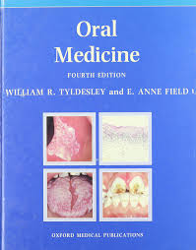
- Text book of Oral Medicine
Author: Tyldesley

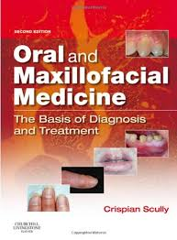
- Oral and Maxillofacial Medicine
The basis of Diagnosis and treatment
Author: CRISPIAN SCULLY

Also recommended:
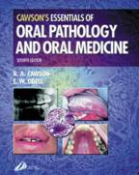
- Essentials of Oral Pathology and Oral Medicine ;
Author: R. A. Cawson, E. W. Odell

E-learing
Learning Resources:
- Required Text (s)
Tyldesley’s Oral Medicine

- Essential References
- Burket’s Oral Medicine
Diagnosis and treatment
- Cawsons Essentials of
Oral Pathology and Oral Medicine
- Differential Diagnosis of Oral Lesions
By Wood and Goaz

- Reference Material (Journals, Reports, etc )

- Electronic Materials, Web Sites etc
www.PubMed.com
- Other learning material such as computer-based programs/CD, professional standards / regulations
- Oral Medicine cases library/ college website

