PHYSIOLOGY STUDY GUIDE
FIRST YEAR BDS
2021-2022

SCOPE OF PHYSIOLOGY DEPARTMENT
Physiology is the study of normal function of human body. It forms the essential baseline knowledge for accurate perception of Pathology, Pharmacology and Medicine in the upcoming years of medical education.
The Department of Physiology, Lahore Medical and Dental College is state of art in providing Physiology education in accordance with the guidelines of PM&DC; also incorporating latest teaching learning methodologies introduced by Department of Medical Education. The faculty to student ratio and laboratory equipment is according to the PM&DC latest criteria.

INTRODUCTION
Medical education is a life-long process and BDS curriculum is a part of the continuum of education from pre-medical education, BDS, proceeding to house job, and post-graduation. PM&DC outlines the guiding principles for undergraduate medical curriculum and has defined the generic competencies and desired outcomes for a medical graduate to provide optimal health care, leading to better health outcomes for patients and societies. These generic competencies set the standards of care for all physicians and form a part of the identity of a doctor. Each competency describes a core ability of a competent dental physician & surgeon. This study guide will give an insight to the students about all these competencies and how to plan their educational activities in the subject of Physiology.
TARGET AUDIENCE
1st year BDS students

DURATION OF COURSE
One year (1st year BDS students)

LEARNING OBJECTIVES (knowledge, skills, attitude)
- To equip the students with specific knowledge, essential skills and appropriate attitude towards the human body
- To be able to understand the functions of each organ system of the body and integrate the functioning with the knowledge of anatomy and biochemistry.
- To comprehend how basic physiological systems interact to overcome the stressful and challenging conditions and why they fail
- To think critically, apply the physiological relevance with the clinical situations and explain the pathophysiology of common diseased conditions
- to become problem solvers, dealing effectively with familiar and unfamiliar problems
- to become lifelong learners
- to direct their own learning and evaluate this activity
- to be able to reason critically and make justifiable decisions regarding patient management
- to practice evidence-based medicine
- to always ensure patient safety
- to adopt a multidisciplinary approach for health promoting interventions
- to be able to demonstrate professional values of self and professional accountability, honesty, probity, and ethics

TEACHING METHODOLOGIES FOR PHYSIOLOGY

- Interactive Lectures: for active involvement of students some engagement trigger like Brainstorming, Think, pair, and share, Buzz session, Incident process, Q&A sessions are introduced.
- Tutorials: set of instructions to complete a task , to an interactive problem solving session
- Small group discussions: active involvement by everyone especially shy and less articulate are encourage to contribute Students learn from each other and everyone gets more practice at expressing their ideas
- Essential skills to be learned in skill lab: provide a safe and protected environment in which the learner can practice clinical skills before using them in real clinical settings, such as performance of CPR.
- Power point presentations by students: delivering positive learning experiences. And excellent communication (written, oral, and listening) skills.
- Practical performance to enhance theoretical concepts
- Self-directed learning is the most vital part to solve problematic cases, go through different learning resources and discuss with peers and the faculty to clarify difficult concepts

ATTENDANCE REQUIREMENT FOR PHYSIOLOGY

- Students are expected to attend all scheduled teaching sessions and examinations
- Attendance in lectures, tutorials, and wards is mandatory. Absence from these sessions will make the students ineligible to sit the final summative assessment.
- A minimum of 75 % attendance in the lectures, wards is mandatory to appear in the summative UHS examination
- Attendance will be recorded through a log-in/log-out biometrics system
- Absence due to illness must be certified appropriately by the General Physician

PHYSIOLOGY SYLLABUS
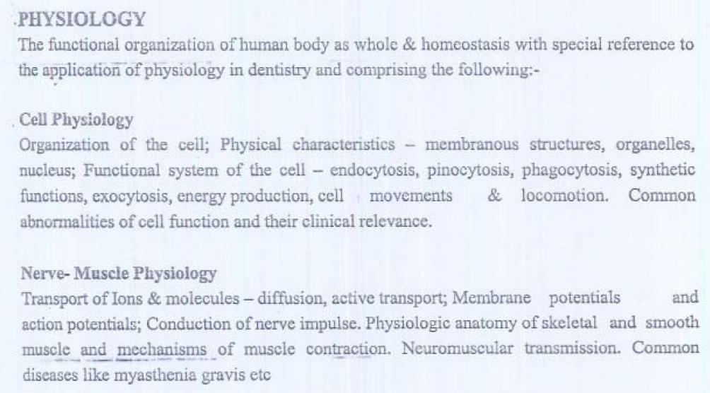
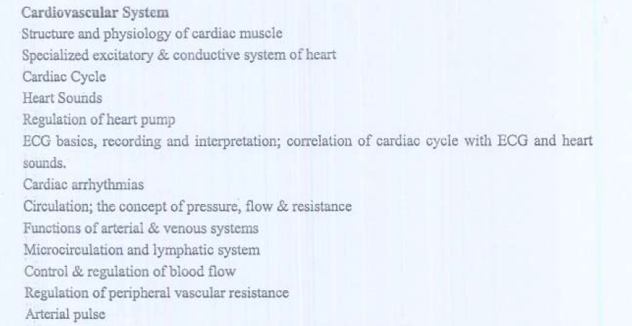
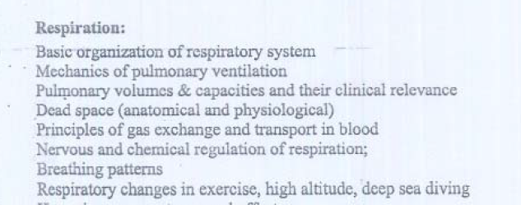
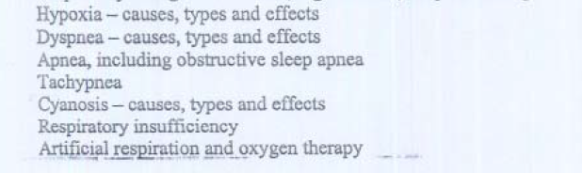
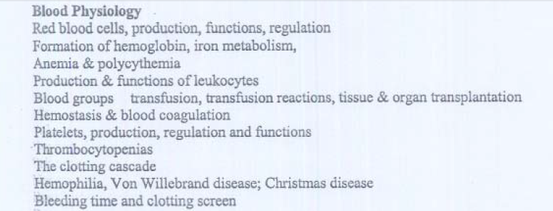
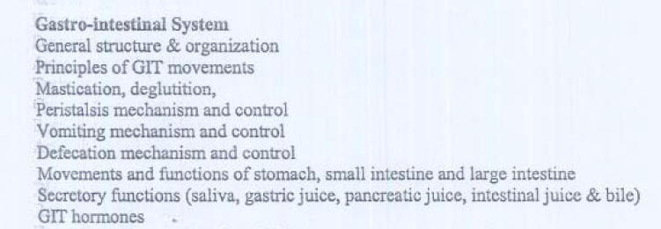
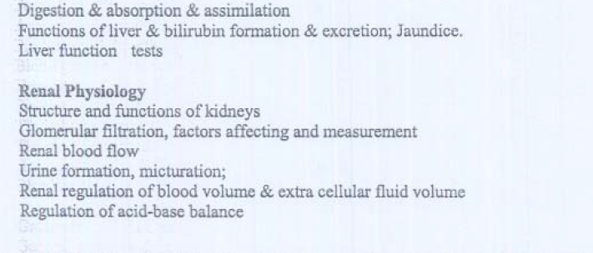
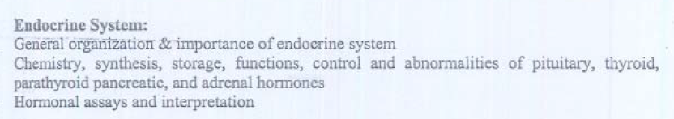
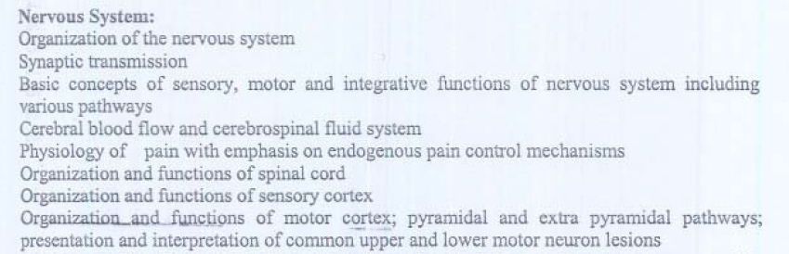
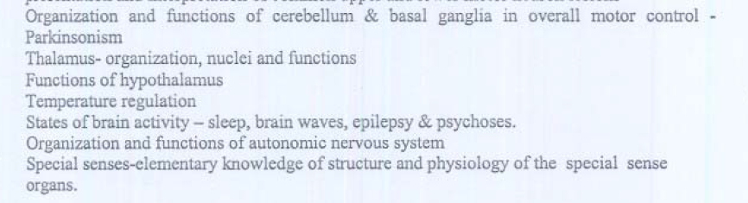
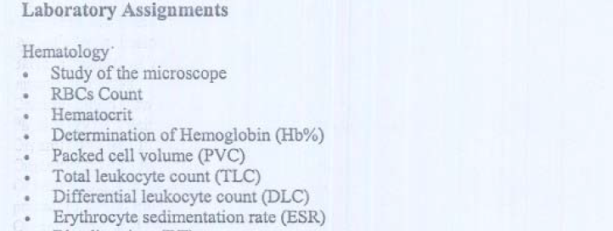
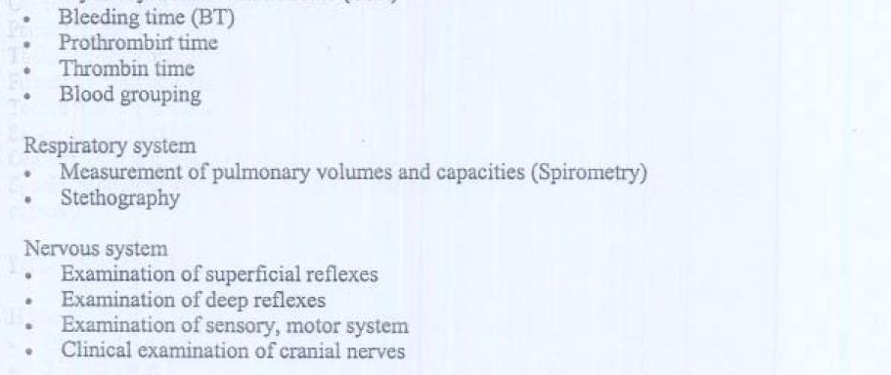
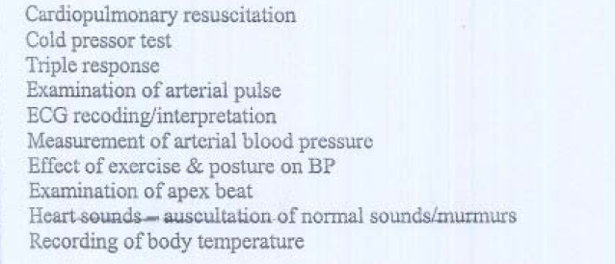

ALIGNMENT OF EDUCATION WITH STUDY HOURS
(1st year BDS)

Sr # | Topic | Tutor | Lectures | Study hours
1 | Respiration | Prof. Anser Asrar | 15 | 14 hours
2. | Endocrinology | Prof. Anser Asrar | 24 | 24 hours
3. | Blood | Prof. Ayesha Siddique | 9 | 9 hours
4. | Heart | Prof. Uzma Zargham | 16 | 16 hours
5. | Renal Physiology | Prof. Uzma Zargham | 20 | 16 hours
6. | Motor system | Prof. Uzma Zargham | 16 | 12 hours
7. | Cell | Prof. Zaima Ali | 8 | 8 hours
8. | Circulation | Prof. Zaima Ali | 22 | 16 hours
9. | Motor system | Prof. Zaima Ali | 14 | 16 hours
10. | Sensory system | Dr. Attiqa Khalid | 14 | 13 hours
11. | Special senses | Dr. Attiqa Khalid | 10 | 12 hours
12. | Environmental physiology | Dr. Attiqa Khalid | 8 | 8 hours
13. | Nerve & Muscle | Dr. Sadia Nazir | 25 | 25 hours
14. | GIT | Dr. Sadia Nazir | 8 | 8 hours
15. | Special senses | Dr. Sadia Nazir | 1 | 1 hours
 | Theory/experimental hours  1hour(2/week)  1.25 hour/week  0.75 hour (3/week)=5.5 |  | 210 | 198 hours
 | Practical hours (1.5 hour/week) |  | 36 | 54 hours

1st YEAR BDS ACADEMIC PLANNER (2021-2022)
SUBJECT OF PHYSIOLOGY

Subject | Physiology
Session | 2021-2022
Total Hours (minimum) | 250 hours
Total no. of sessions in 36 weeks | 7 per week X 36= 252 hours
Duration of each session per week | 45 minutes = 3  60 minutes = 2  75 minute = 1  90 minute = 1
Course of Action | February 2022 to November 2022

Faculty (Department of Physiology)

- Prof. Ansar Asrar (Professor and Head of Dept.)
- Prof. Ayesha Siddique
- Prof. Uzma Zargham
- Prof. Zaima Ali
- Dr. Attiqa Khalid (Associate Professor)
- Dr. Sadia Nazir (Associate Professor)

WEEK TOPIC

WEEK 01 UNIT I - Introduction to
Physiology: The Cell and General
Physiology.
UNIT VI - Blood Cells, Immunity,
and Blood Coagulation

WEEK 02 UNIT I - Introduction to
Physiology: The Cell and General
Physiology.
UNIT VI - Blood Cells, Immunity
and Blood Coagulation

WEEK 03 UNIT I - Introduction to Physiology: The Cell and General
Physiology.
UNIT VI - Blood Cells, Immunity,
and Blood Coagulation

WEEK 04 UNIT I - Introduction to
Physiology: The Cell and General
Physiology.
UNIT VI - Blood Cells, Immunity,
and Blood Coagulation

WEEK 05 UNIT V - The Body Fluids and Kidneys
UNIT II - Membrane Physiology,
Nerve, and Muscle

WEEK 06 UNIT V - The Body Fluids and Kidneys
UNIT II - Membrane Physiology,
Nerve, and Muscle

WEEK 07 UNIT V - The Body Fluids and Kidneys
UNIT II - Membrane Physiology,
Nerve, and Muscle

WEEK 08 UNIT V - The Body Fluids and Kidneys
UNIT XI - The Nervous System: C. Motor and Integrative Neurophysiology

WEEK 09 UNIT V - The Body Fluids and Kidneys
UNIT XI - The Nervous System: C. Motor and Integrative Neurophysiology

WEEK 10 UNIT IX - The Nervous System: A. General Principles and Sensory Physiology
UNIT XII - Gastrointestinal Physiology

WEEK 11 UNIT IX - The Nervous System: A. General Principles and Sensory Physiology
UNIT XII - Gastrointestinal Physiology

WEEK 12 UNIT IX - The Nervous System: A. General Principles and Sensory Physiology
UNIT XII - Gastrointestinal Physiology

WEEK 13 UNIT VII – Respiration
UNIT III - The Heart

WEEK 14 UNIT VII – Respiration
UNIT III - The Heart

WEEK 15 UNIT VII – Respiration
UNIT III - The Heart

WEEK 16 UNIT VII – Respiration
UNIT III - The Heart

WEEK 17 UNIT VII – Respiration
UNIT III - The Heart

WEEK 18 UNIT XIV – Endocrinology
UNIT X - The Nervous System: B. The Special Senses

WEEK 19 UNIT XIV – Endocrinology
UNIT X - The Nervous System: B. The Special Senses

WEEK 20 UNIT XIV – Endocrinology
UNIT X - The Nervous System: B. The Special Senses

WEEK 21 UNIT XIV – Endocrinology and Reproduction
UNIT X - The Nervous System: B. The Special Senses

WEEK 22 UNIT XIV – Endocrinology and Reproduction
UNIT X - The Nervous System: B. The Special Senses

WEEK 23 UNIT XIV – Endocrinology and Reproduction
UNIT X - The Nervous System: B. The Special Senses

WEEK 24 UNIT VII – summer vacation

WEEK 25 UNIT IV - summer vacation

WEEK 26 UNIT IV - summer vacation

WEEK 27 UNIT IV - summer vacation

WEEK 28 UNIT IV - The Circulation
UNIT VIII - Aviation, Space, and
Deep-Sea Diving Physiology

WEEK 29 UNIT IV - The Circulation
UNIT VIII - Aviation, Space, and
Deep-Sea Diving Physiology

WEEK 30 UNIT IV - The Circulation
-Introduction to skin

WEEK 31 UNIT IV - The Circulation
-Function of skin

WEEK 32 UNIT IV - The Circulation
UNIT XIII - Metabolism and Temperature
Regulation

WEEK 33 UNIT IV - The Circulation
UNIT XIII - Metabolism and Temperature
Regulation

WEEK 34 UNIT IV - The Circulation

WEEK 35-36 UNIT IV - The Circulation
-SEND UP AND PREP LEAVE.

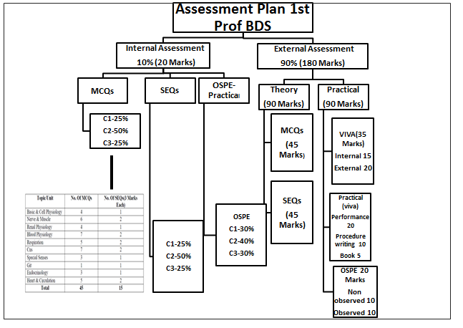
ASSESSMENT METHODOLOGY
Formative
Class tests
Send up
Viva—semi structured
Practical--OSPE
Summative
UHS professional examination
Test Format
- Theory: 1) Single best multiple choice questions. 2) Short essay question
- Structured Viva:
- Practical performance
- OSPE (observed & non-observed stations)
Internal assessment policies
10% based upon the Departmental test and 90% UHS Professional Examination

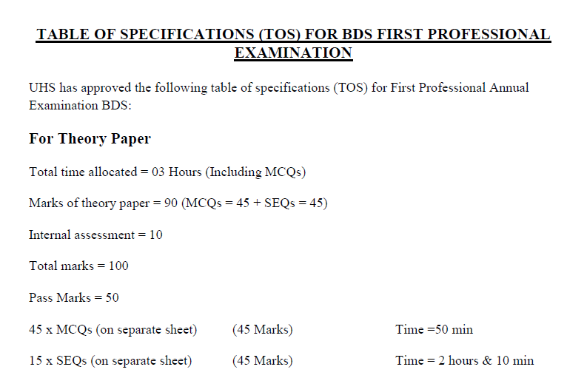
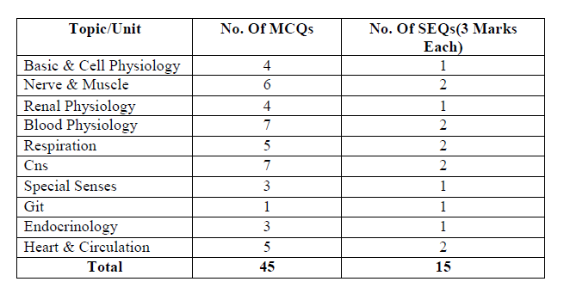

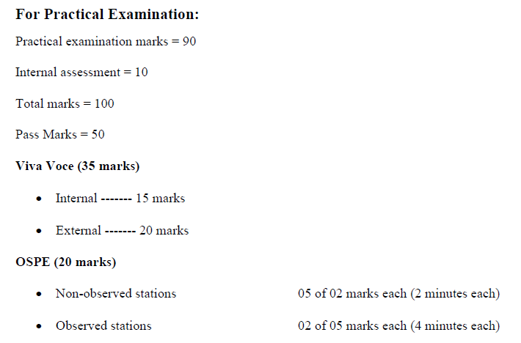
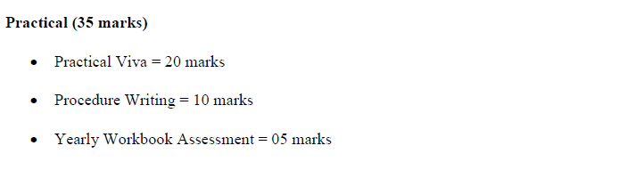

TEST SCHEDULE 1st YEAR BDS (2021-2022)

Test 1 | 10-03-2022
Test 2 | 11-04-2022
Test 3(Term test 1) | 9-05-2022
Test 4 | 10-06-2022
Test 5 | 22-07-2022
Test 6 (Term test 2) | 15-08-2022
Test 7 | 09-09-2022
Test 8 | 23-09-2022
Test 9(term Test 3) | 7-10-2022
Test 10 | 31-10-2022
Send up | 30-11-2022

LEARNING RESOURCES
1. Departmental library
2. IT library
3. Recommended books
4. Reference books
RECOMMENDED BOOKS
1. Textbook of Physiology by Guyton and Hall, Latest Ed.
2. Review of Medical Physiology by William F. Ganong, Latest Ed.
3. Physiology by Berne and Levy, Latest Ed.
4. Human Physiology: The Basis of Medicine by Gillian Pocock, Christopher D. Richards, Latest Ed.
5. Physiological Basis of Medical Practice by John B. West and Taylor, 12th
REFERENCE BOOKS
Board Review Series by Linda S Costanzo
Human Physiology from Cells to System by Lauralee Sherwood
Essentials of Medical Physiology by Mushtaq Ahmed

