Oral Pathology
Study Guide
3rd YEAR BDS 2022

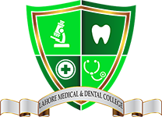
College of Dentistry
Lahore Medical & Dental College

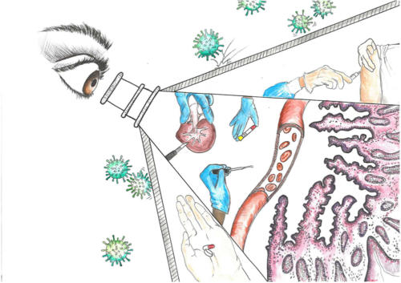
Oral Pathology Curriculum (2022)

Course Director:

Prof. Dr. Sadia Iqbal
B.D.S, M.Phil. (PB), MMEd. (Master in Medical Education)
Head of the Department Oral Pathology

Contributors:
Dr. Momin Ayub Marath B.D.S ,MSc. (UK) Associate Professor
Dr. Rummana Aqeel B.D.S, M.Phil Assistant Professor
Co contributors:
Dr.Aiza Mahmood B.D.S Demonstrator

Dr. Maida Iqbal B.D.S Demonstrator

Contents

1 | Vision of UHS
2 | Vision of LMDC
3 | Curriculum Map
4 | Time table of 3rd year BDS
5 | Course Objectives
6 | Feedback on Oral presentation
7 | Time Allocation for Academic Activities
8 | Assessment plan of Oral Pathology Department
9 | Educational strategies

Vision of UHS

UHS shall continue to strive for producing a human resource par at excellence to cater for the health needs of the people of Punjab and Pakistan

Mission Statement of Lahore Medical and Dental College
Our mission is to train future leaders of medicine who set new standards in knowledge, caring and compassion.

CURRICULAR MAP OF ORAL PATHOLOGY

By the end of 3rd Year learners will be able to achieve Cognitive proficiency in Differential Diagnosis on the basis of
- Pathogenesis
- Etiological factors
- Histopathological Features
- Radiographic Features
- Treatment Modalities

- Lectures
- Lab practical
- Tutorial
- Small group discussions
- Self study
- Assignment
- Class presentation
- Poster presentation
- 3D Models
- Hands - on
Course Duration: 200 hrs
- Lectures – 70
- Practical – 30
- Self Directed Learning – 30
Ratio – 50:35:15
- Lecture Hall
- Oral pathology Lab
- Microscopes
- Study Models
- Library
- E books
Cognition Domain: MCQs ; SEQs,SAQs ; VIVA
Psychomotor Domain: OSPE ;Drawing of Histopathological Slides ; Identification of slides on microscope
Affective Domain: Portfolio
PMC Guidelines for Oral Pathology Course
Facilitators:
Professor
Associate Professor
Assistant Professor
Demonstrators
Supporting staff:
Lab Technician

TIME TABLE 3rd YEAR BDS

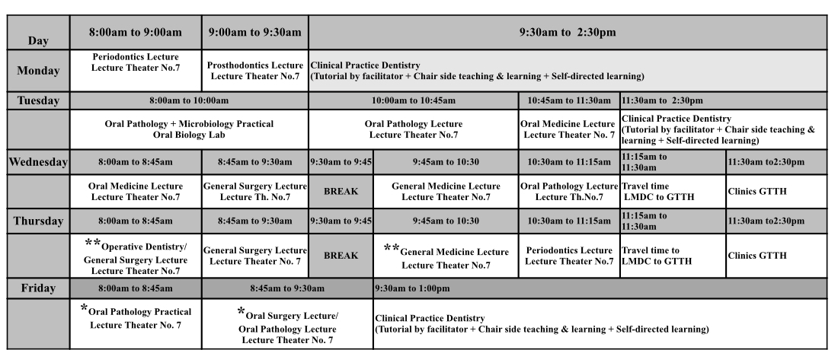

INTRODUCTION
- “Oral pathology is the specialty of dentistry and discipline of pathology that deals with the nature, identification, and management of diseases affecting the oral and maxillofacial regions.”
- The department provides an overview of oral and maxillofacial pathology including the clinical Histopathology and Radiographic presentation of Oral diagnosis and pathogenesis. The study of microscope, tissue processing, diagnostic tests and advanced techniques are also included.
TARGET AUDIENCE
3RD Year BDS Students

General Objectives of Undergraduate:
Able to:
1-Recognize normal oral anatomy and variations of normal.
2- Relate oral pathology to other dental sciences.
3- Distinguish features of common oral diseases that help in its clinical diagnosis.
4- Achieve cognitive proficiency in differential diagnosis for common oral lesions or diseases.
5- Explain the pathogenesis and etiological factors of various oral diseases.
6- Connect histopathological features of oral lesions to its clinical presentation and management.
7- Demonstrate the skills of analytical problem solving, investigation, and self-development in the field of oral pathology.

TEACHING AND LEARNING STRATEGIES
(i) Strategies for achieving cognitive objectives
• Interactive lectures using audio visual aids on power point presentation
• Group discussions in form of large group and small group
• Collaborative learning
• Self-study and reading from learning resources
(ii) Strategies for achieving psychomotor objectives
• Focusing the histological slides on microscope
• Identification of normal histological structures on slides under different magnification
• Drawing and labeling the histological slides on practical notebooks
(iii) Strategies for achieving affective objectives
• Interaction with peers, group members, teachers, support staff etc.
• Group discussions (small and large)
• Oral presentations by students Knowledge and understanding :

TEACHING METHODOLOGIES FOR ORAL PATHOLOGY

- Interactive Lectures
- Tutorials
- Practicals
- Power point presentations by students
- Small group discussions
- Assignment
- Self-directed learning
- Discussion on last year UQS

ATTENDANCE REQUIREMENT FOR ORAL PATHOLOGY

- Students are expected to attend all scheduled teaching sessions and examinations
- Attendance in lectures and practicals is mandatory. Absence from these sessions will make the students ineligible to sit the final summative assessment.
- A minimum of 75 % attendance in the lectures, practicals is mandatory to appear in the summative UHS examination
- Attendance will be recorded through a log-in/log-out biometrics system
- Absence due to illness must be certified appropriately by the General Physician

LEARNING RESOURCES
Recommended books
.1 Oral and Maxillofacial Pathology. 4 th Edition by BW Neville, DD Damn,CA
Allen, A Chi.
2. Oral Pathology Soams, J.V. 4th Edition
3. Cawsons Essentials of Oral Pathology & Oral Medicine 9th Edition.
4. Oral Pathology Clinical Pathological Correlation Regezi , Joseph A, 7th Edition
5. Shafers Textbook of Oral Pathology 7th Edition.

Time Allocation for Academic Activities

Teaching activity | FREQUENCY/YEAR
Lectures | 110
Practicals/ Tutorial | 36
Small group Discussion
Self Directed Learning

COURSE OUTLINE (syllabus)
The course outline is as follows :

- Introduction to Oral Pathology
- Advanced diagnostic staining methods
- Wound healings
- Development disturbances of teeth & bone
- Infection of teeth & bone
- Odontogenic tumor
- Oral infections
- Epithelial disorders
- Bone pathology
- Immune mediated disorders
- Connective tissue lesions
- Salivary glands disorders
- Physical and chemical injuries
- Disorders of blood

PRACTICAL OUTLINE:
- List of topics of Practicals & OSPE Examination :
- Cysts of Head & Neck
- Periapical cyst
- Dentigerous cyst
- Odontogenic Keratocyst
- Gingival cyst
- Branchial cyst
- Dermoid cyst
- Dental Caries / Pulp / Periapical Inflammation
- Dentinal caries
- Chronic pulpitis
- Pulp stones / Linear calcification
- Periapical abscess
- Periapical granuloma
- Hyperplastic pulpitis

- Benign Fibro-osseous / Bony lesion
- Periapical cemental dysplasia
- Fibrous dysplasia
- Giant cell lesions
- Cherubism
- Periapical giant cell granuloma
- Central giant cell granuloma
- Pagets disease
- Osteoma
- Osteochondroma
- Malignant Bone tumors
- Osteosarcoma
- Giant cell tumor
- Ewing sarcoma
- Multiple myeloma
- Burkitt’s lymphoma
- Epithelial odontogenic tumors
- Follicular ameloblastoma
- Reticular ameloblastoma
- Basaloid ameloblastoma
- Squamoid ameloblastoma
- Adenomatoid odontogenic tumor
- Odontogenic myxoma
- Calcifying epithelial odontogenic tumor
- Ameloblastic fibroma
- Ameloblastic odontoma
- Soft tissue lesions
- Lipoma
- Lieomyoma
- Neurofibroma / Schwannoma
- Fibrosarcoma
- Hemangioma / Lymphangioma
- Granular cell lesion
- Rhabdomyosarcoma
- Leiomyosarcoma
- Infectious diseases
- Herpes vesicle
- TB Granuloma
- Actinomycosis
- Candida scrapings / Epithelial biopsy
- Aspergillosis scrapings
- Papillary lesions
- Squamous cell papilloma / Viral wart
- Verrucous carcinoma
- Granuloma pyogenicum
- Pigmented lesions
- Intradermal / Intramucosal nevus
- Melanoma

- Vesiculobullous lesions
- Pemphigus vulgaris
- Mucous membrane pemphigoid
- Ulcerative lesions
- Non-specific ulcers
- White lesions
- Dysplastic mucosa
- Fordyce’s granules
- Cheek biting
- Benign idiopathic leukoplakia
- Squamous cell carcinoma
- Basal cell carcinoma
- Salivary gland Tumors
- Pleomorphic adenoma
- Warthins tumor
- Mucoepidermoid carcinoma
- Canalicular tumor
- Oncocytoma
- Adenoid cystic carcinoma
- Acinic cell tumor
- Mucocele
- List of Gross specimens
- Hemi-mandibulectomy specimen ( Squamous cell carcinoma)
- Hemi-mandibulectomy specimen
- Multiloculated lesions( Ameloblastoma)
- Sarcoma
- Hemiglossectomy( Squamous cell carcinoma)
- Lymph nodes
- Tuberculous
- Lymphomas
- Metastatic
- Maxillary specimen
- Lipoma
- Dermoid cyst
- Pleomorphic adenoma ( salivary glands)
- Other salivary gland lesions
- Teeth
- Carious teeth
- Pulp polyp
- Dilaceration
- Gemination / Fusion
- Concresence
- Odontoma
- Periapical granuloma
- Accessory roots / cusps
- Dens evaginatus
- Dens invaginatus
- Talons cusp
- Enamel pearls
- Turners tooth

Assessment plan of Oral Pathology Department

- Small group discussion on different topics allotted to 3rd year BDS students
- Individual Presentations on allotted topics
- Posters related to different topics of Oral Pathology
- 3-D Models of gross specimens

PRESENTATION TOPICS
- Following topics were allotted to students for presentations:
SR. NO. | TOPIC
14- | Introduction/Classification of Connective Tissue disorders – Focal Fibrous Hyperplasia
15- | Peripheral Ossifying Fibroma
16- | Peripheral Giant Cell Granuloma
17- | Inflammatory Fibrous Hyperplasia
18- | Inflammatory Papillary Hyperplasia
19- | Hyperplastic Gingivitis
20- | Hereditary Gingival Fibromatosis
21- | Drug Induced Gingival Hyperplasia
22- | Classification of Benign neoplasms -Fibromatosis/Myofibromatosis/Desmoplastic Fibroma
23- | Nodular Fasciitis
24- | Benign Fibrous Histiocytoma
25- | Benign Solitary Fibrous Tumor
26- | Fibrosarcoma/Malignant Fibrous Histiocytoma/Malignant Solitary Fibrous Tumor
27- | Introduction of Neural tissue neoplasms- Traumatic neuroma
28- | Introduction of Neural tissue neoplasm – Palisaded Encapsulated Neuroma
29- | Multiple Endocrine Neoplasia Syndrome
30- | Neurilemoma
31- | Neurofibroma
32- | Granular Cell Tumor
33- | Congenital Gingival Granular Cell Tumor
34- | Neuroectodermal Tumor of Infancy
35- | Neurogenic Sarcoma
36- | Leiomyoma
37- | Rhabdomyosarcoma
38- | Lipoma
39- | Liposarcoma
40- | Pyogenic Granuloma
41- | Hemangioma
42- | Lymphangioma
43- | Angiosarcoma
44- | Kaposi Sarcoma
45- | Soft Tissue Osteoma
46- | Osseous & Cartilagenous Choristoma
47- | Myositis Ossificans

Feedback on Oral Presentation

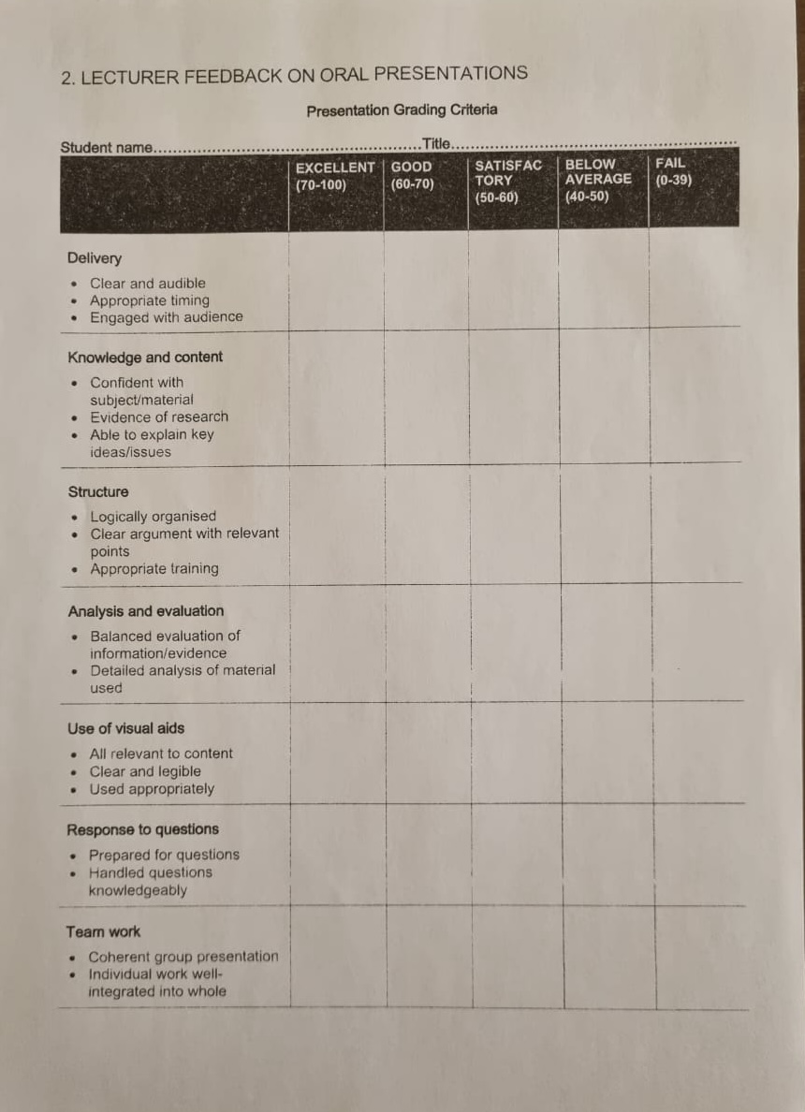

Assessment
FORMATIVE ASSESSMENT METHODOLOGY
SUMMATIVE ASSESSMENT METHODOLOGY

FORMATIVE ASSESSMENT METHODOLOGY
- Topics test : At the completion of every chapter. Consisting of MCQs, SEQs OSPE on pattern of university exam
- Term test after 3-4 months of academic session: Conducted in coordination with other subjects
- Send up examination

SUMMATIVE ASSESSMENT METHODOLOGY
3RD PROFESSIONAL UNIVERSITY EXAMINATION

Total Marks: 200

WRITTEN EXAM = 90 Marks VIVA/ORAL & PRACTICAL INTERNAL ASSESSMENT = 20 Marks
EXAMINATION = 90 Marks
SEQs: 45 Marks Attendance: 5 Marks
MCQs: 45 Marks
Internal assessment marks=10 Class Tests: 4 Marks
Presentation: 4 Marks
3D Models/Posters: 3 Marks
Log Book/Send-Up: 2 Marks
Behavior/Attitude: 2 Marks

Practical Total Marks =100
- VIVA 50 marks
Examiner I (Internal) =25 Marks Examiner 2 (External)=25 Marks
- Practical (OSPE • Draw and label Task) 40 marks
OSPE Total = 15 Stations
Practical Notebook 5 marks
- Internal Assessment marks =10

ALIGNMENT OF EDUCATION WITH STUDY HOURS (3rd year BDS )

Topics | No.of lectures
Introduction to Oral Pathology, Advanced diagnostic, staining methods and wound healing | 1
Introduction to Oral Pathology, Advanced diagnostic, staining methods and wound healing
Immune-mediated disorders | 8
REVISION - Immune-mediated disorders
Group Discussion -Immune-mediated disorders
Immune – Mediated Disorders –TEST (OSPE/VIVA)
Immune – Mediated Disorders – TEST (OSPE/VIVA)
Developmental disturbances of oral region | 8
REVISION -Developmental disturbances of oral region
Group discussion
Developmental disturbances of oral region – TEST
Developmental disturbances of oral region – TEST
Physical & Chemical Injuries | 8
REVISION - Physical & Chemical Injuries
GROUP DISCUSSION -Physical & Chemical Injuries
Odontogenic Cysts | 6
REVISION - Odontogenic Cysts
GROUP DISCUSSION - Odontogenic Cysts
Epithelial Disorders | 10
REVISION - Epithelial Disorders
GROUP DISCUSSION -Epithelial Disorders
Odontogenic Tumors

 | 5
Physical & chemical injuries –TEST
Physical & chemical injuries –TEST
Odontogenic Tumors | 3
REVISION- Odontogenic Tumors
GROUP DISCUSSION
Odontogenic cysts – TEST
Odontogenic cysts – TEST
Oral Infections | 8
Oral Infections
Odontogenic Cyst / Tumors – MID-TERM
Odontogenic Cyst / Tumors – MID-TERM
Oral Infections
Oral Infections
REVISION-Oral Infections
GROUP DISCUSSION-Oral Infections
Epithelial Disorders-TEST
Epithelial Disorders – TEST
Bone lesions | 8
REVISION-Bone lesions
GROUP DISCUSSION-Bone lesions
Bone lesions – TEST
Bone lesions – TEST
Infections of teeth & bone | 8
REVISION-Infections of teeth & bone
REVISION-Infections of teeth & bone
Salivary gland disorders | 8
REVISION-Salivary gland disorders
GROUP DISCUSSION-Salivary gland disorders
Test- Infections of teeth & bone/Salivary gland disorders
Connective tissue disorders | 8
Blood disorders | 3
Blood disorders
Blood disorders
Wound Healing | 1
Wound Healing
Lecture-How to attempt paper in exams?
Lecture-How to attempt OSPE?
Group discussion related to different topics.
Send-up exam
VIVA
VIVA

3rd yr BDS
LECTURE ALLOCATION 2022- 23
Total # of lectures in 36 weeks: = 95

 | Nov-Dec | Jan | Feb | March | April | May | June | July | August | TOTAL
Introduction to Oral Pathology | 1 |  |  |  |  |  |  |  |  | 1
Infections of Teeth and Bone | 4 | 4 |  |  |  |  |  |  |  | 8
Oral Infections |  | 8 |  |  |  |  |  |  |  | 8
Salivary Gland Disorders |  |  | 8 |  |  |  |  |  |  | 8
Wound Healing |  |  |  | 1 |  |  |  |  |  | 1
Immune-Mediated Disorders |  |  |  | 8 |  |  |  |  |  | 8
Epithelial Disorders |  |  |  |  | 10 |  |  |  |  | 10
Diseases of Blood |  |  |  |  |  | 3 |  |  |  | 3
Development Disturbances of the Oral Regions |  |  |  |  |  |  | 8 |  |  | 8
Connective Tissue Disorders |  |  |  |  |  |  |  | 8 |  | 8
Cysts of the Oral Regions |  |  |  |  |  |  |  |  | 8 | 8
Physical and Chemical Injuries |  |  |  |  |  |  |  |  | 8 | 8
Bone Lesions |  |  | 8 |  |  |  |  |  |  | 8
Odontogenic Tumors |  |  |  |  |  | 8 |  |  |  | 8
TOTAL | 5 | 12 | 16 | 9 | 10 | 11 | 8 | 8 | 16 | 95

TIMELIINE ORAL PATHOLOGY TOPICS 2022-2023

1 | April | - Introduction to Oral Pathology  - Infections of Teeth and Bone  - Developmental Disturbances of Oral Regions
2 | May | - Developmental Disturbances of Oral Regions  - Immune Mediated Disorders
3 | June | - Immune Mediated Disorders
4 | July | - Salivary Gland Disorders  - Mid Term Assessment  - Bone Lesions
5 | August | - Bone Lesions  - Epithelial Disorders
6 | September | - Connective Tissue Disorders
7 | October | - Connective Tissue Disorders  - Odontogenic Cyst
8 | November | - Diseases of Blood
9 | December | - Odontogenic tumors
10 | January | - Physical and Chemical Injuries  - Wound Healing  - Send-Up assessment
11 | February/March | Prep leave for Professional Exam

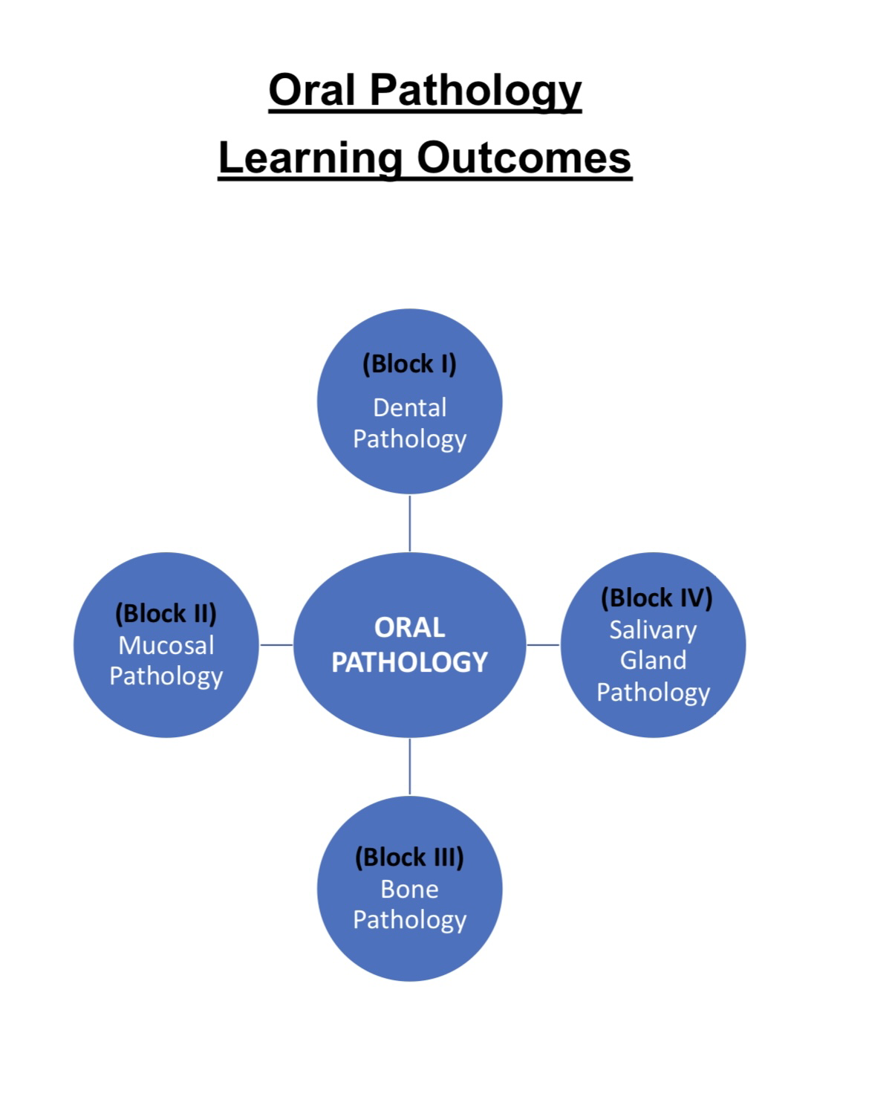

BLOCK I - DENTAL PATHOLOGY
Sr. | Topic | Learning Objectives | Instructional strategies | Assessment Tools
1 | Abnormalities of teeth | 1. Define and enlist all developmental anomalies affecting the number, size shape and structure of teeth.  2. Differentiate between  developmental and environmental abnormalities.  3. Describe in detail the pathogenesis, clinical and radiographical presentation of Amelogenesis Imperfecta, Dentinogenesis Imperfecta and Dentine dysplasia.  4. Diagnose common dental pathologies and apply the knowledge in the clinical practice. | Interactive lecture | MCQs  SEQs  OSPE  Viva
2 | Dental Caries | 1. Define caries and enlist etiological factors.  2. Discuss the etiological factors in detail.  3. Explain the interplay of  etiological factors and their role in the pathogenesis of caries in detail.  4. Describe the histopathological features of enamel and dentine caries.  5. Corelate the mechanism of  carious lesion with the clinical presentation. | Interactive lecture  & SGD | MCQs & SEQs  OSPE  Viva
3 | Pulp Pathology | 1. Define and classify pulpitis.  2. Describe the etiology and pathogenesis of pulpitis.  3. Explain the clinical, radiographical and histopathological features of pulpitis.  4. Define and enlist causes of periapical periodontitis.  5. Briefly discuss sequelae of periapical  periodontitis.  6. Explain the spread of  periapical inflammation with emphasis on details of Cellulitis (Ludwig's Angina).  7. Relate and apply the concepts of pulp pathology in clinical practice. | Interactive lecture | MCQs  SEQs  OSPE  Viva
4 | Other Disorders | 1. Define disorders of eruption and  shedding of teeth.  2. Define and briefly  describe the predisposing factors of various types of Non- bacterial tooth loss.  3. Define and explain the pathogenesis along with the clinical and histological features of internal and external tooth resorption.  4. Classify causes of tooth discoloration with brief knowledge of underlying causative agents.  5. Relate and apply the concepts in clinical practice. | Interactive Lecture | MCQs  SEQs  OSPE  Viva
5 | Periodontal Pathology | To avoid overlapping with Periodontology we do not teach this topic.

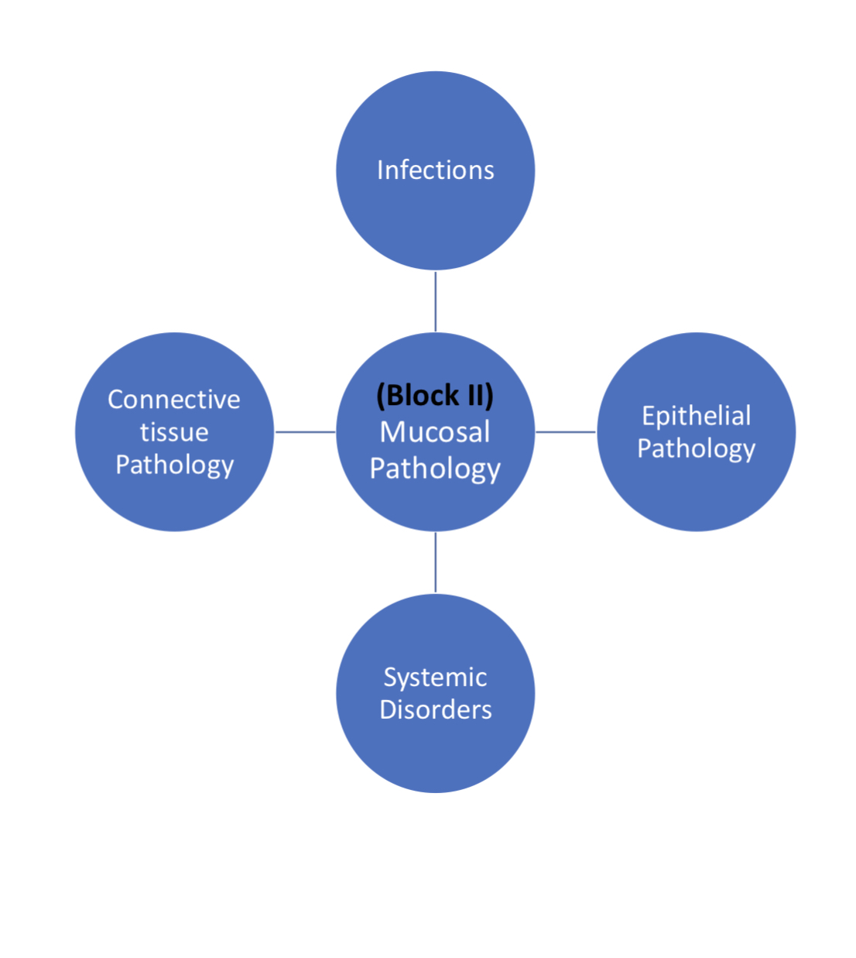

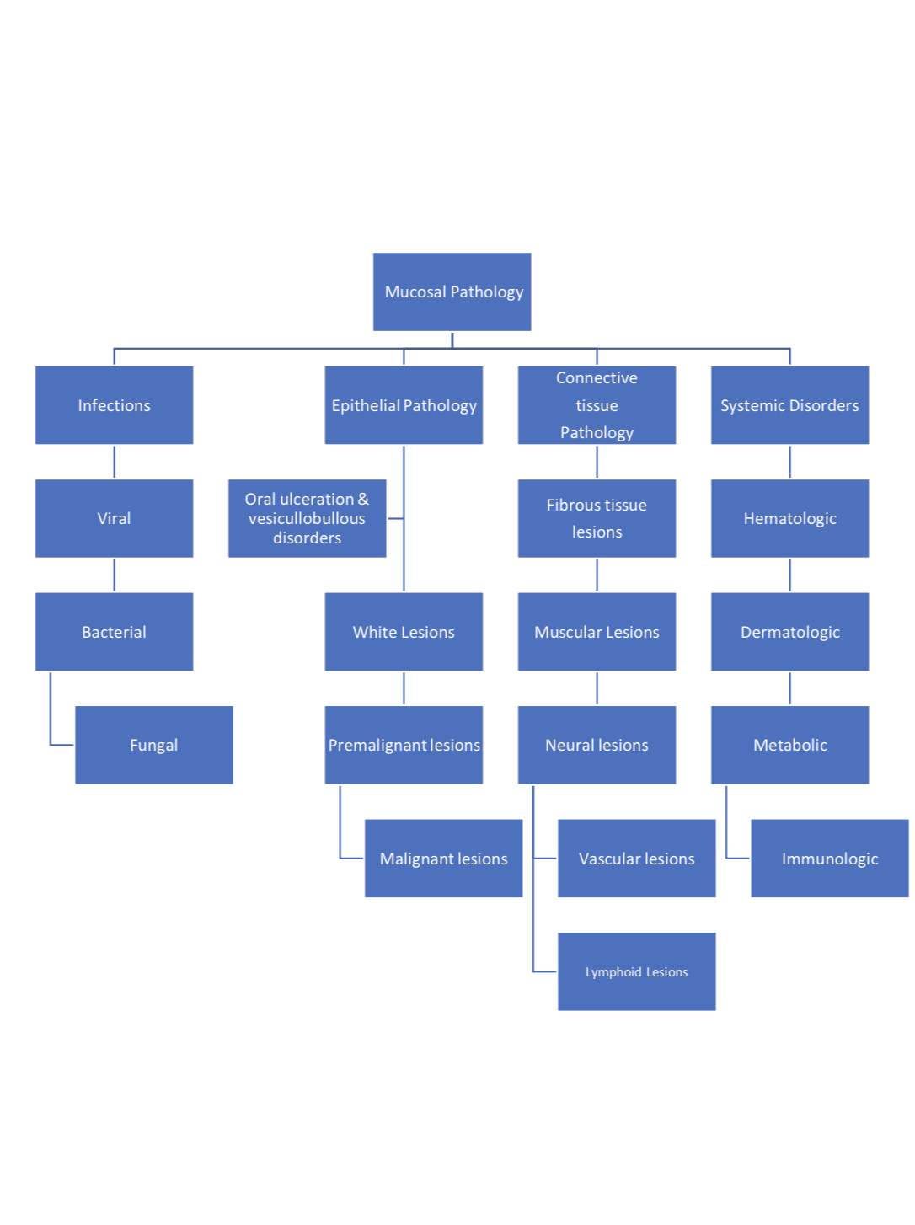

BlOCK II (MUCOSAL PATHOLOGY)

Sub-Category: Infections

Sr. | Topic | Learning Objectives | Instructional strategies | Assessment Tools
1 | Viral Infections | 1. Enlist different types of viral infections affecting the oral cavity.  2. Explain in detail the predisposing factors, etiology, clinical presentation and histology of herpes simplex virus, varicella zoster virus, paramyxo virus, Epstein barr virus and HIV infection.  3. Briefly describe the oral manifestations of Coxackie virus, Human papilloma virus and cytomegalo virus infection.  4. Generate differential diagnosis of various viral infections.  5. Co-relate and apply the knowledge in the clinical practice. | Interactive Lecture | MCQs  SEQs  OSPE  Viva
2 | Bacterial Infections | 1. Enlist common bacterial infections along with causative bacterial organism affecting the oral cavity.  2. Briefly describe the pathogenesis, clinical presentation and histopathology of Noma, syphilis and leprosy.  3. Describe in detail the pathogenesis, clinical presentation, histopathology and diagnostic tests required for Actinomycosis and Tuberculosis. | Interactive Lecture | MCQs  SEQs  OSPE  Viva
3 | Fungal Infections | 1. Differentiate between basic types of fungal infections.  2. Explain in detail the predisposing factors, clinical presentation and histology of oral candida infection.  3. Generate differential diagnosis of various fungal infections.  4. Correlate and apply the knowledge in the clinical practice.  5. Enlist deep fungal infections along with very brief clinical and histological appearance. | Interactive Lecture  Histopathological slide study | MCQs  SEQs  OSPE  Viva

Sub-Category: Epithelial Pathology

Sr. | Topic | Learning Objectives | Instructional strategies | Assessment Tools
1 | White Lesions | 1. Define and classify white lesions of oral cavity with brief description of histological features.  2. Briefly describe the hereditary and  traumatic white  lesions.  3. Define and explain in  detail the clinical presentation and histology of leukoplakia, oral sub mucous fibrosis and lichen planus.  4. Define and differentiates  between the cytological and histological features of Dysplasia in detail.  5. Generate the differential diagnosis of various white lesions.  6. Relate this knowledge in clinical practice. | Interactive Lecture  Histopathological slide study | MCQs  SEQs  OSPE  Viva
2 | Premalignant Lesions | 1. Define and enlist premalignant lesions.  2. Highlight the importance of these lesions in clinical practice.  3. Explain the histopathological features in detail. | Interactive Lecture  SDG | MCQs  SEQs  OSPE  Viva
3 | Oral Ulcerations & Vesiculobullous disorders | 1. Define and enlist causes of oral ulceration. 2. Describe the  etiology, pathogenesis, clinical presentation and histological features of Recurrent Aphthous ulcers in detail. | Interactive Lecture  Histopathological slide study | MCQs  SEQs  OSPE  Viva
4 | Malignant Lesions | 1. Define and elaborate etiological factors of OSCC.  2. Explain the mechanism of  carcinogenesis at  molecular level.  3. Elaborate and  distinguish between clinical features of early and advanced oral cancer particularly OSCC.  4. Identify and describe in detail the  histopathological  features in detail.  5. Relates the prognosis  of OSCC with the grading and staging systems.  6. Enlist variants of OSCC.  7. Define and classify, with emphasis on the clinical presentation of benign and malignant melanocytic lesions.  8. Interpretation of these concepts in clinical practice. | Interactive Lecture  Histopathological slide study  SDG | MCQs  SEQs  OSPE  Viva

Sub-category: Connective Tissue Pathology

Sr. | Topic | Learning Objectives | Instructional strategies | Assessment Tools
1 | Fibrous Lesions | 1. Enlist various fibrous tissue lesions with brief description of clinical and histological features.  2. Generate differential diagnosis based on the clinical and histological features.  3. Enlist and discuss in detail the clinical aspect of various denture induced lesions affecting the oral mucosa.  4. Relate and apply this knowledge in the clinical practice. | Interactive Lecture  Histopathological slide study | MCQs  SEQs  OSPE  Viva
2 | Muscular Lesions | 1. Define and classify connective tissue lesions on the basis of tissue of origin.  2. Distinguish between benign and malignant neoplasms of smooth and skeletal muscle origin.  3. Demonstrate and diagnose  histopathological features of common lesions with the help of light microscopy. | Interactive Lecture | MCQs  SEQs  OSPE  Viva
3 | Neural Lesions | 1. Define and enlist various connective tissue lesions of  neural origin.  2. Briefly describe the  clinical and histological features of Granular cell tumor, Schwannoma and neurofibromatosis.  3. Demonstrate and diagnose  histopathological features of common lesions with the help of light microscopy. | Interactive Lecture | MCQs  SEQs  OSPE  Viva
4 | Vascular Lesions | Define and classify vascular lesions.  2. Compare vascular anomalies like  hemangiomas and AV malformations on clinical grounds. | Interactive Lecture  Histopathological slide study | MCQs  SEQs  OSPE  Viva
5 | Lymphoid Lesions | 1. Define and classify malignant lymphoma.  2. Explain the clinical presentation in detail.  3. Briefly describe the histology of basic types of lymphomas. | Interactive Lecture  Histopathological slide study | MCQs  SEQs  OSPE  Viva

Sub-category: Systemic Pathology

Sr. | Topic | Learning Objectives | Instructional strategies | Assessment Tools
1 | Hematological Disorders | All of these are major components of Oral Medicine syllabus, thus are not taught in Oral Pathology. | Not Applicable | Not Applicable
2 | Dermatological Disorders
3 | Immunological Disorders
4 | Nutritional Disorders

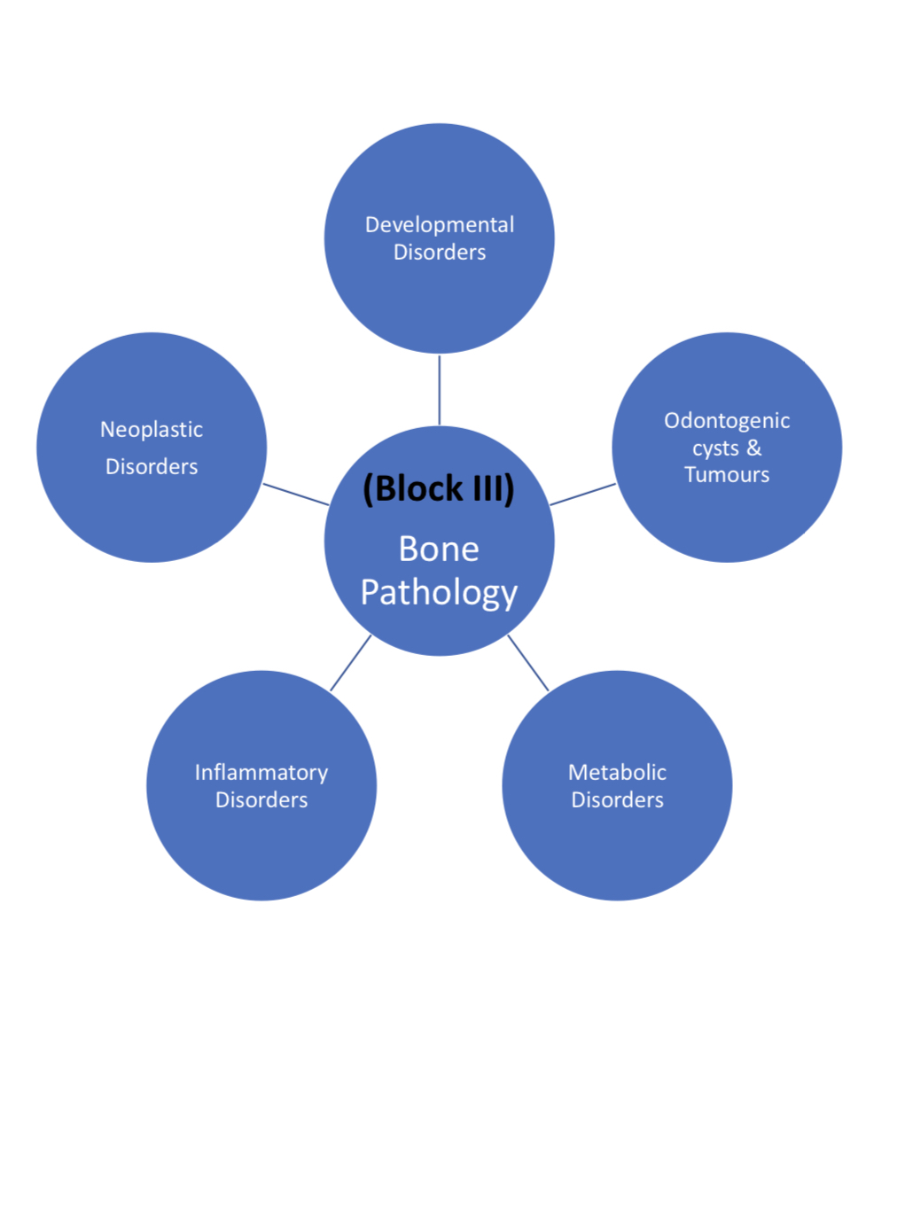

BLOCK III - BONE PATHOLOGY

Sr. | Topic | Learning Objectives | Instructional strategies | Assessment Tools
1 | Odontogenic Cysts & Tumors | 1. Define and classify  Odontogenic  cysts & tumors.  2. Explain  pathogenesis of common odontogenic cysts.  3. Describe clinical,  radiographical and histopathologic al features of Jaw cysts and tumors.  4. Identify and draw  histopathologic al features of common cysts and tumors through microscopy.  5. Generate differential  diagnosis of various jaw cysts and tumors.  6. Relate and apply  knowledge in clinical practice. | Interactive Lecture  Histopathological slide study  SGD | MCQs  SEQs  OSPE  Viva
2 | Developmenta l Disorders | 1. Define and classify bone lesions.  2. Define fibro-  osseous lesions.  3. Compare and  distinguish between various fibro-osseous lesions.  4. Generate differential  diagnosis on clinical and radiographical grounds.  5. To be able to apply their knowledge on patient diagnosis. | Interactive Lecture  Histopathological slide study | MCQs  SEQs  OSPE  Viva
3 | Metabolic Disorders | 1. Define and enlist metabolic bone disorders.  2. Briefly distinguish among various  metabolic bone disorders clinically, radiographically and histopathologically.  3. Discuss the oral manifestations of these disorders. | Interactive Lecture | MCQs  SEQs  OSPE  Viva
4 | Inflammatory Disorders | 1. Define and classify osteomyelitis.  2. Explain in detail the etiology and pathogenesis.  3. Discuss the clinical, radiographical and histopathological features in relation to clinical practice. | Interactive Lecture  Histopathological slide study | MCQs  SEQs  OSPE  Viva
5 | Neoplastic Disorders | 1.Define and classify neoplastic bone lesions.  2. Discuss and distinguish  between common benign and malignant neoplasms clinically, radiographically and histopathologically, that includes osteomas, osteoblastoma, osteosarcoma and chondrosarcoma.  3. Generate differential  diagnosis based on clinical and radiographical grounds.  4. Relate this knowledge in  clinical practice. | Interactive Lecture  Histopathological slide study | MCQs  SEQs  OSPE  Viva

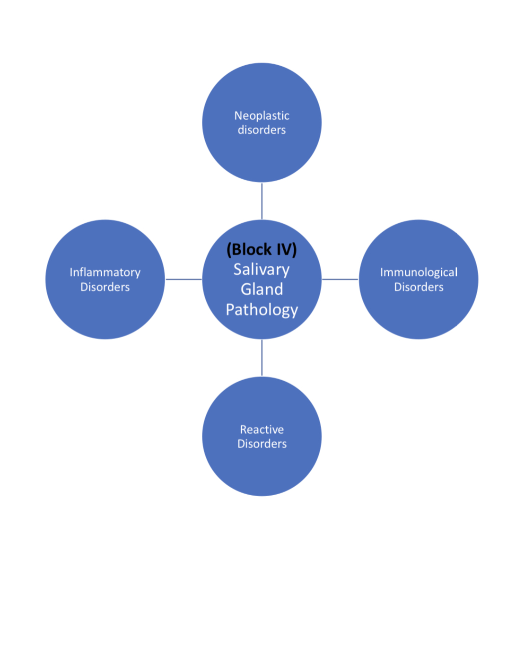

BLOCK lV -SALIVARY GLAND PATHOLOGY

Sr. | Topic | Learning Objectives | Instructional strategies | Assessment Tools
1 | Inflammatory Disorders | 1. Define and enlist different types of sialadenitis.  2. Discuss the causative agents along with differential diagnosis of acute/chronic sialadenitis based on clinical grounds. | Interactive Lecture | MCQs  SEQs  OSPE  Viva
2 | Immunological Disorders | 1. Define and classify Sjogren’s syndrome.  2. Discuss the pathogenesis and clinical presentation in detail.  3. Evaluate and diagnose based on various lab tests.  4. Apply knowledge in the clinical practice. | Interactive Lecture | MCQs  SEQs  OSPE  Viva
3 | Reactive Disorders | 1. Enlist and define various reactive lesions such as mucocele, sialolithiasis, sialadenitis, sialorrhea and necrotizing sialometaplasia.  2. Identify the underlying causative agent along with the characteristic clinical presentation of these conditions.  3. Diagnose such lesions in clinical practice. | Interactive Lecture  Histopathological slide study | MCQs  SEQs  OSPE  Viva
4 | Neoplastic Disorders | 1. Classify salivary gland neoplasms.  2. Differentiate between benign and malignant salivary gland tumor on clinical grounds.  3. Explain in detail the clinical and  histological features of common benign tumor like pleomorphic adenoma and warthin’s tumor.  4. Discuss in detail the clinical and  histological features of common malignant tumor like mucoepidermoid carcinoma, ca ex- pleomorphic adenoma and adenoid cystic carcinoma.  5. Generate differential diagnosis of various salivary gland pathologies with application in the clinical setting. | Interactive Lecture  Histopathological slide study | MCQs  SEQs  OSPE  Viva

